Conductor survey

Some materials are good thermal conductors.
Some materials are insulators.
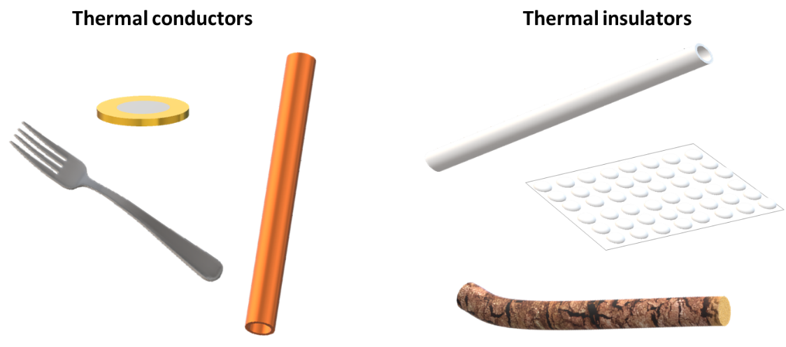

What do you think about conductors and insulators?
For each statement, tick (✓) one column to show what you think.
Statements |  | I am sure this is right | I think this is right | I think this is wrong | I am sure this is wrong
A | Metals are good thermal conductors
B | Trapped air is a good insulator
C | Insulators have a higher temperature than good conductors
D | Insulators can help to keep things cold
E | Energy moves quickly through a conductor by heating

Physics > Big idea PMA: Matter > Topic PMA1: Heating and cooling > Key concept PMA1.3: Thermal conduction
Diagnostic question
Conductor survey

Overview
Learning focus: | Heating makes the particles in a material move more quickly. Heating raises the temperature quickly throughout a good thermal conductor, and very slowly through a good thermal insulator.
Observable learning outcome: | Identify materials that are good thermal conductors or good thermal insulators
Question type: | Confidence grid
Key words: | Conductor, insulator, temperature, heating

What does the research say?
Students are typically very good at identifying materials that are thermal conductors or insulators, and recognise in particular that metals are good conductors. However, this does not mean that students have a clear understanding of conduction and insulation. It is fairly common for students to describe good conductors as materials that heat or cool quickly (Erickson and Tiberghien, 1985). This is subtly different to understanding that energy is quickly transferred through a conductor by heating.
Students often link properties of an object with what will happen: if it feels cold it will cool, and if it feels warm it will warm. In a study Chu et al. (2012) found that more than a quarter of 14- to 16-year olds (n=344) thought that materials like wool have the ability to warm things up. The scientific approach is to consider the system, to identify where the temperature is higher and to consider how the energy can be transferred by heating to where the temperature is smaller.
This question explores whether students hold any of these misunderstandings.
Ways to use this question
Students should complete the confidence grid individually. This could be a pencil and paper exercise, or you could use an electronic ‘voting system’ or mini white boards and the PowerPoint presentation.
If there is a range of answers, you may choose to respond through structured class discussion. Ask one student to explain why they gave the answer they did; ask another student to explain why they agree with them; ask another to explain why they disagree, and so on. This sort of discussion gives students the opportunity to explore their thinking and for you to really understand their learning needs.
Differentiation
You may choose to read the questions to the class, so that everyone can focus on the science. In some situations it may be more appropriate for a teaching assistant to read for one or two students.
Expected answers
Answers A, B, D and E are correct.
C is wrong.
How to respond - what next?
Most students should recognise that metals are good thermal conductors, although they may not be familiar with the term ‘thermal conductor’.
The insulating properties of air can be demonstrated by seeing how close to the side of a Bunsen flame the ‘live end’ of a match can be held before it lights. It is surprisingly close!
The BEST ‘Key concept: PMA1.1 Temperature’ covered the idea that if objects are in thermal equilibrium then they are all have the same temperature, even if they feel warmer or cooler than each other. (The zeroth law of thermodynamics.)
The definitions of a conductor and insulator need to be applied in answers D and E. It is likely that a significant number of students will get D wrong because they have the misunderstanding that insulators feel warm because they have a higher temperature.
If students have misunderstandings about which materials are good thermal conductors or insulators, it can help to set the task of sorting a range of objects into thermal conductors and insulators. Asking students to work in pairs or small groups to write a set of instructions for how to do this can encourage social construction of new ideas through dialogue.
The following BEST ‘response activity’ could be used in follow-up to this diagnostic question:
- Response activity: Hot rods
Acknowledgments
Developed by Peter Fairhurst (UYSEG).
Images: Peter Fairhurst (UYSEG).
References
Chu, H.-E., et al. (2012). Evaluation of Students' Understanding of Thermal Concepts in Everyday Contexts. International Journal of Science Education, 34:10, 1509-1534.
Erickson, G. and Tiberghien, A. (1985). Heat and Temperature. In Driver, R., Guesne, E. & Tiberghien, A. (eds.) Children's Ideas In Science. Milton Keynes and Philadelphia: Open University Press.

